1. Create User from **UI** https://dev-qwallity.herokuapp.com/.

Username= Ani1994

1. Change user role in DB

Update users

set role_Id = '1'

where username= 'Ani1994' and ID= '55555749';

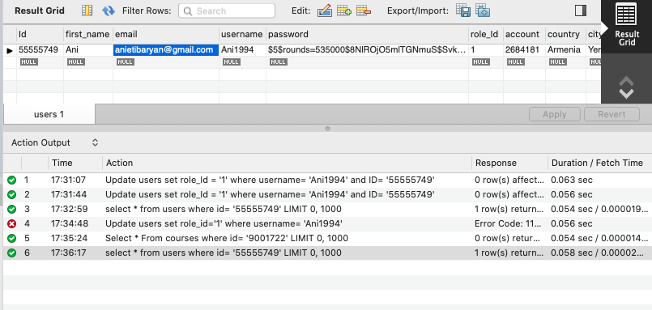

1. Insert Course in database

Select * from courses;

Insert Into courses(title, body, author, date_created, coursetype, price)

Values ('Black Box', 'A', 'Ani', ‘2020-05-24 10:34:09, '2', '50');

Select * from courses where author= ‘Ani’;

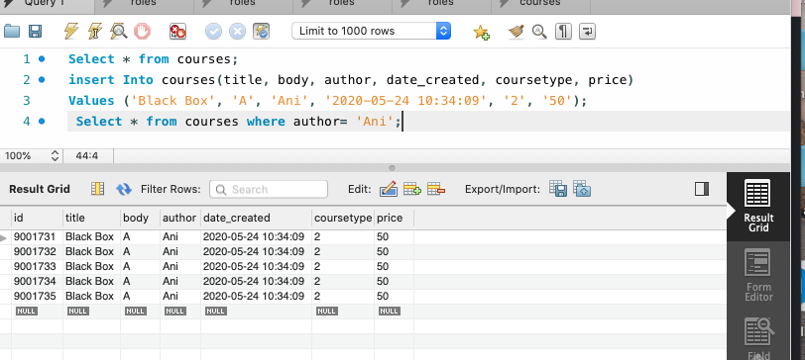

1. Update Course name

Select * from courses;

Update courses

set title= 'Armenia 6'

where id= '9000334'; and price= ‘45’;

sss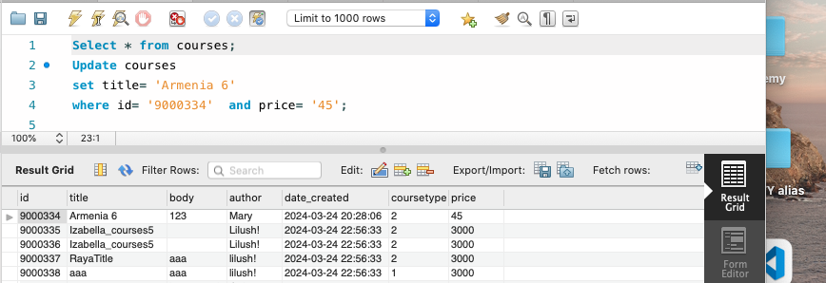

1. Select all advanced courses

select * from courses

where coursetype= '2';

1. Delete your added course

Delete from courses

where id= '9001722';

Select * from courses where id= ‘90001722’;

